LAB 05

Python if and else Statements

- Basic Task: Write a program that checks if a given number is positive, negative, or zero.
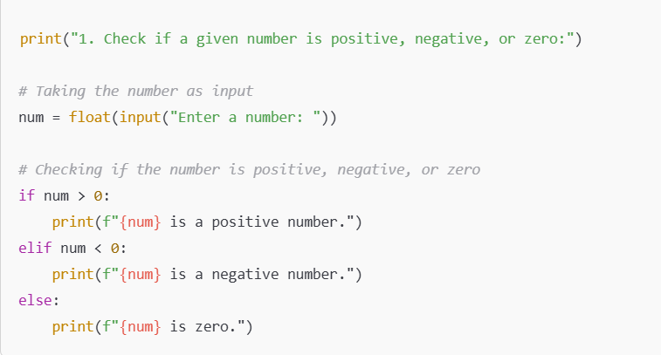
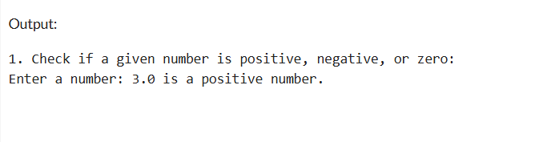

- Intermediate Task: Write a program that takes user input and determines whether it's a even or odd.
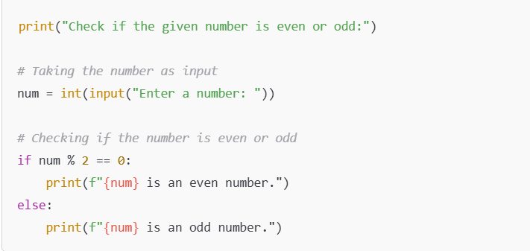
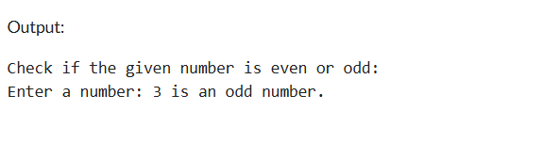
- Advanced Task: Create a program that asks user to print:
  - "Excellent" if marks are above 80
  - "Good" if marks are between 60 and 80
  - "Needs Improvement" if marks are below 60
